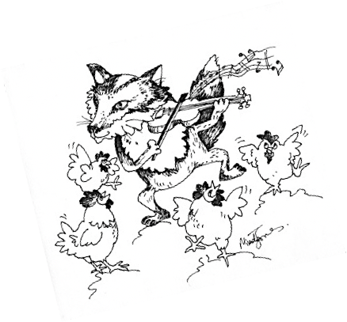
FiddlyNess Fiddle Camp Registration

Name: _________________________________________________
Address: _______________________________________________
Town/Postal Code: _______________________________________
Email: _________________________________________________
Telephone: _____________________________________________
Food Allergies: __________________________________________
Level (circle one):
Beginner (no raw beginner) Intermediate Advanced
Camp Fees:
Adult (16 and older) (before April 15 $400) $440 ____
Child (15 & under) (before April 15 $230) $260 ____
Onsite, no lessons $50 ____
Note: anyone under 16 must be accompanied by a guardian
University Student $350 ____
Accommodations:
Camping non-powered ($10/unit/day) $40 ____
Camping with power ($25/unit/day) $100 ____
Cabins: please visit www.nesscore.com
Meals:
Full Meals (Monday Supper – Friday Lunch)
Adult $210 ____
Child (8 and under) $135 ____
Lunches Only (Tuesday Lunch – Friday Lunch)
Adult $100 ____
Child (8 and under) $75 ____
Snacks and coffee only $35 ____
Total: __________
Please mail form with a cheque made payable to:
FiddlyNess Fiddle Camp Inc.
2407 Kelvin Ave
Saskatoon SK
S7J-0T4
or email completed form to info@fiddlyness.com and e-transfer.
Thank you and let the tunes begin!

